# Safety Week Agenda

## Day 1 – Monday 23rd September, 2024

**Themes**

* Airside Safety
* Worker Safety

**Presentations/Activities**

* None today

**Resources**

* Skybrary - <https://www.skybrary.aero/index.php/Category:Ground_Operations>
* ACI World - <https://cfapp.icao.int/tools/RSP_ikit/story_content/external_files/Airside%20Safety%20Handbook%202010.pdf>
* FAA - <https://www.icao.int/SAM/Documents/2018-RST_PTY/2.5%20Establishing-Runway-Safety-Culture.pdf>
* Transport Canada - <http://tc.canada.ca/en/aviation/commercial-air-services/aviation-occupational-health-safety>
* Canadian Centre for Occupational Health and Safety - <https://www.ccohs.ca>
* Skybrary - <https://www.skybrary.aero/index.php/The_Human_Factors_%22Dirty_Dozen%22>

## Day 2 – Tuesday 24th September, 2024

**Themes**

* Environmental Safety

**Presentation**

* Presentation by Fort McMurray Airport Authority - Multi-stakeholders’ collaborative operations of safety for evacuation flights and evacuees from Fort Chipewyan wildfires in 2023 (10 – 11am PST/1 – 2pm EST)
* <https://teams.microsoft.com/l/meetup-join/19%3ameeting_MjExNmY3ZDktNjU5YS00ZTE5LTkyMjUtMTNlN2QwNzBlODgy%40thread.v2/0?context=%7b%22Tid%22%3a%227a97ec4d-15b6-4eb1-8ee8-0ac1aac74bf0%22%2c%22Oid%22%3a%22190709eb-9069-4307-843c-d247552b7a58%22%7d>
* <https://www.internationalairportreview.com/article/190690/evacuation-by-air-at-fort-mcmurray-international-airport/>
* 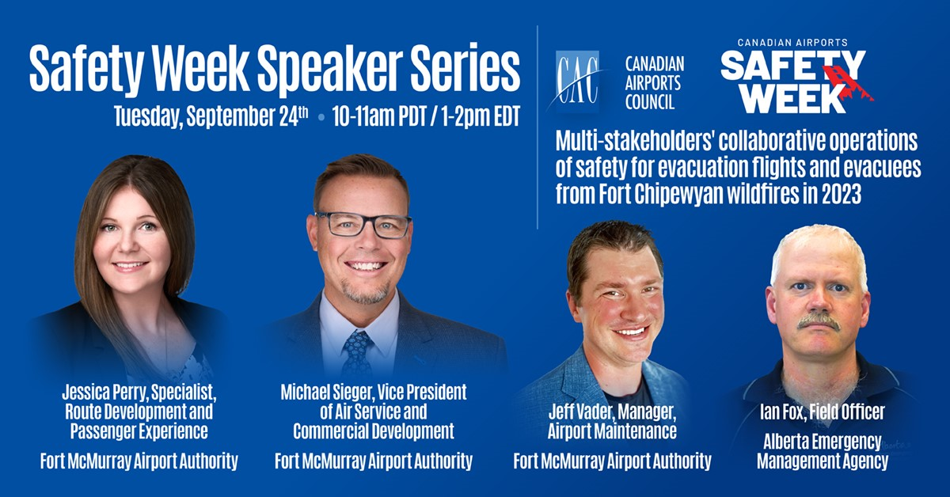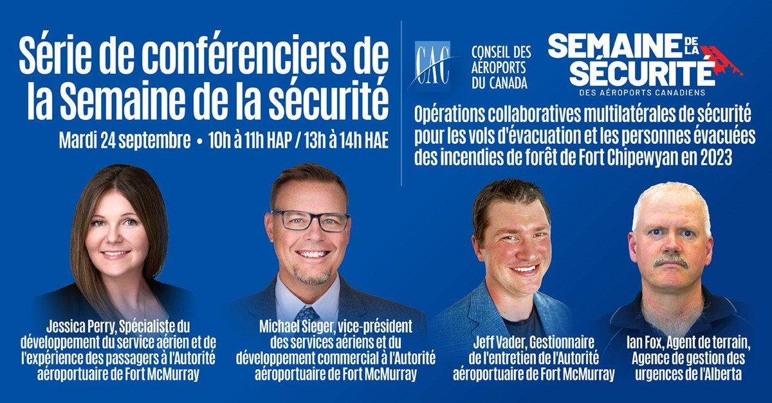

**Resources**

* ICAO - <https://www.icao.int/environmental-protection/Pages/default.aspx>
* ICAO - <https://www.icao.int/environmental-protection/Documents/EMS_at_Airports.pdf>
* World Bank - <https://documents.worldbank.org/en/publication/documents-reports/documentdetail/665381496052174463/environmental-health-and-safety-guidelines-for-airports>

## Day 3 – Wednesday 25th September, 2024

**Themes**

* Security Safety

**Presentations/Activities**

* Presentation by Phil Morris (YOW) - Accountability Management Systems (10-11am PST/1-2pm EST)
* <https://teams.microsoft.com/l/meetup-join/19%3ameeting_YTg4ODY2OWEtMjIyZi00NjMxLWIwMGItMGUyY2FkMTljZmMy%40thread.v2/0?context=%7b%22Tid%22%3a%227a97ec4d-15b6-4eb1-8ee8-0ac1aac74bf0%22%2c%22Oid%22%3a%22190709eb-9069-4307-843c-d247552b7a58%22%7d>
* 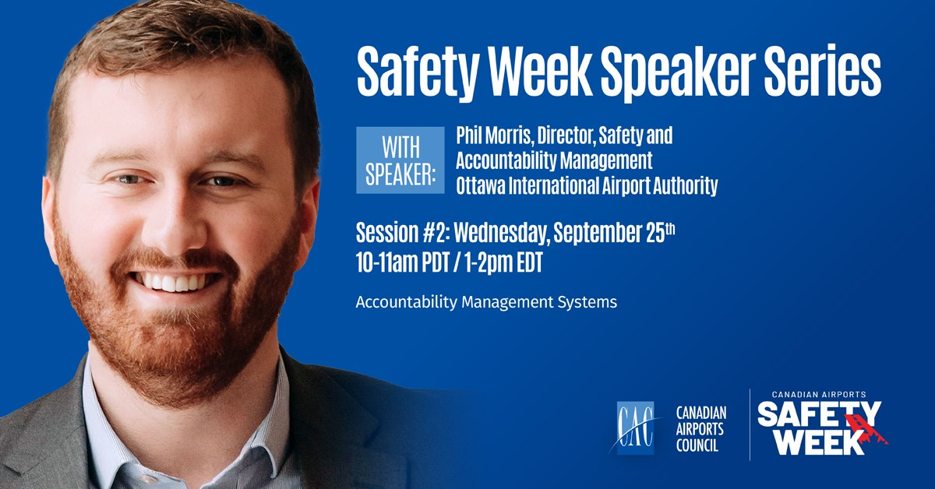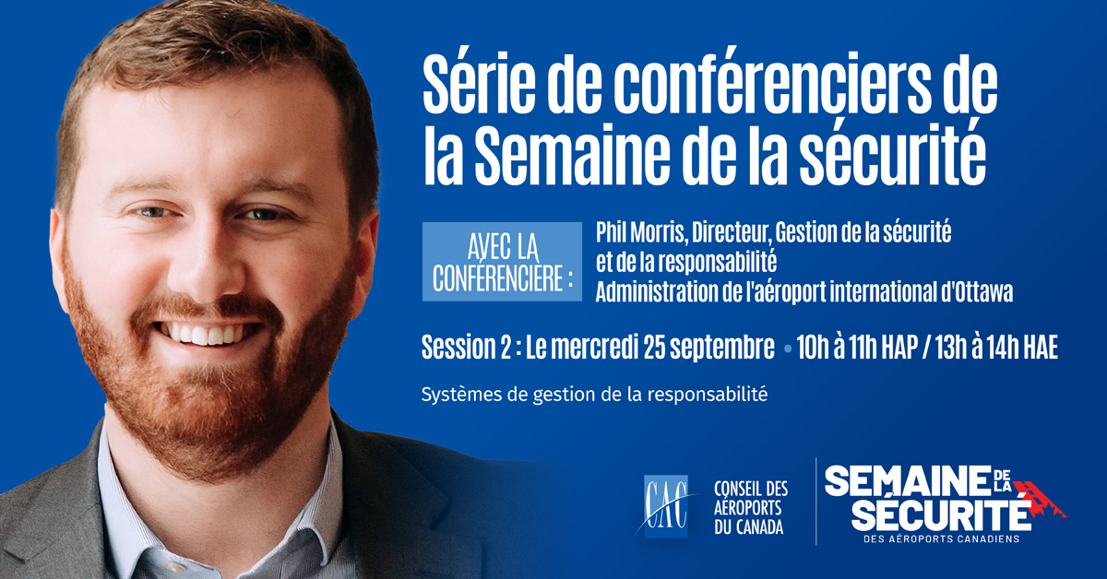

**Resources**

* Transport Canada - <https://tc.canada.ca/en/aviation/aviation-security>
* EIA - [https://flyeia.com/human-trafficking-training-resources](https://can01.safelinks.protection.outlook.com/?url=https%3A%2F%2Fflyeia.com%2Fhuman-trafficking-training-resources&data=04%7C01%7Cspower%40flyeia.com%7C5dd38e82188248dee39d08d9835b0a38%7C986ed830d02741d998e2a2c285aa3d5c%7C1%7C0%7C637685249300352590%7CUnknown%7CTWFpbGZsb3d8eyJWIjoiMC4wLjAwMDAiLCJQIjoiV2luMzIiLCJBTiI6Ik1haWwiLCJXVCI6Mn0%3D%7C1000&sdata=o9i9tfW7WqtEJiKGOVmx74lxxlaTihlP%2BOOI2MS2XbQ%3D&reserved=0)
* # Not In My City - <https://notinmycity.ca>
* # SeeSayDay - <https://www.dhs.gov/see-something-say-something/seesay-day>
* DHS Webinar – Empower & Equip: How to Spot and Report Suspicious Activity this #SeeSayDay

## Day 4 – Thursday 26th September, 2024

**Themes**

* Psychological Safety
* Hazard Reporting

**Presentations/Activities**

* None today

**Resources**

* Skybrary - <https://www.skybrary.aero/index.php/Airport_Bird_Hazard_Management>
* International Airport Review - <https://www.internationalairportreview.com/article/109323/aviation-psychologist-wellbeing-passenger-staff/>
* National Safe Skies Alliance – Mental Health and Airport Security <https://www.sskies.org/images/uploads/subpage/PARAS_0033.MentalHealthAirportSecurity_.FinalReport_.pdf>
* AIN - <https://www.ainonline.com/aviation-news/business-aviation/2021-03-01/building-strong-safety-culture-human-factors-training>

## Day 5 – Friday 27th September, 2024

**Themes**

* Foreign Object Debris (FOD)

**Activities**

* FOD Walk

**Resources**

* Skybrary - <https://www.skybrary.aero/index.php/Foreign_Object_Debris_(FOD)>
* The FOD Control Corporation - <https://www.fodcontrol.com/setting-up-a-fod-program/>
* Boeing - <http://www.boeing.com/commercial/aeromagazine/aero_01/textonly/s01txt.html>
* FAA - <https://www.faa.gov/airports/airport_safety/fod/resources/>